Completing the Class Diagrams using Behavioral Modeling
Name
Institution
Date

Completing the Class Diagrams using Behavioral Modeling
An elaborate hospital-related EHR Sharing System hinges on the robustness of the software design to yield the primary objectives that include enhancing safe record keeping, seamless order placement, and provision of an e-prescription capability. The design phase of hospital-related system specifies the structure of the written instructions and facilitate error-free transition because it incorporates the ‘what’ and ‘how’ attributes (Satzinger, Jackson, & Burd, 2015). Evidently, the reliance on the Unified Modeling Language (UML), which is an open standard of programming language, merits because it facilitates the efficacy of an object-oriented development methodology (Ehlmann, 2009). The notable influence of the UML tools relates to the development of logical class diagram that is necessary for an object-oriented modeling methodology (ibid). The connection between the classes and object influences the interactions as well as the algorithmic structure in a hospital-related EHR Sharing System.
Specifically, the use of a UML Class Diagram serves critical functions in the design of a hospital-focused EHR Sharing System. The class diagram provides a sketch that communicates pertinent aspects of the EHR system is an integral function because it enhances documentation and subsequent modeling (Loudon & Loudon, 2014). Equally, the provision of a robust blueprint in static-based modeling is necessary because it defines the roles, relationship, and attributes of a particular diagram (Ehlmann, 2009). The critical compartments of a class diagram include the abstract name of the class at the top, the attributes that display the relevant properties of a class being modeled in the middle, and the operating segment to outline the visibility parameters (ibid). Evidently, the purpose of the inherent overview is to expound on the cadres of associations in class diagram architecture in static modeling and improve the dynamic modeling using sequence diagrams, activity models, as well as a state diagram.
Extended Class Diagram with Association
Figure 1: Class Diagram with role and multiplicity on the end of the Association
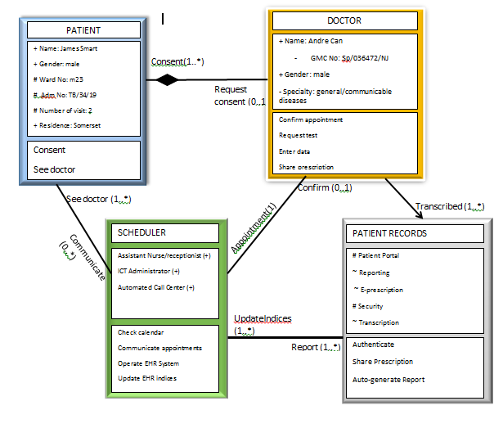
The figure above portrays the blueprint concept of the proposed hospital EHR-Sharing System. The static structure of the EHR Sharing System depicts four classes, instances, and the relationship among the classes. A review of the static structure exemplifies the pertinent sets of the notions that facilitate an object-oriented modeling methodology (Open University, 2011). Further, each class diagram entails the three compartments that include the ‘class name’, ‘attributes’, and ‘operation methods’ in the top, middle, and bottom level of the rectangle respectively.
Evidently, the “PATIENT CLASS” reveals the distinctive properties of a client that includes his name, gender, number of visitation, and tag-number, which influences the ability to initiate an appointment with the doctor in addition to accord an informed consent. Equally, the “SCHEDULER CLASS” represents a class that establishes the connection between “PATIENT’ and “DOCTOR” by ascertaining the availability as well as communicate the appointment using a standard association among the three classes. Importantly, a standard association depicts a bi-directional relationship that creates awareness about the existence of the relationship among the parties. Specifically, once the receptionist or assistant nurse become aware of Mr. Smart’s need to visit Dr. Can, he or she checks the calendar, disseminate the information to the “DOCTOR” class. The “SCHEDULER” further updates once the “PATIENT RECORDS” to reflect the successful appointment in the system.
Moreover, the provision of a unidirectional association in figure 1 above enhances the adaptability of the EHR Sharing System because it enhances the coupling effects of the objects in the classes. The unidirectional association establishes the reporting structure because the reporting class becomes is the only party made aware of the existence of a relationship (Ferreira, 2017). Therefore, the known class represents the recipient of an action that includes ‘transcription’ from the “DOCTOR” class or ‘updated indices’ from the “SCHEDULER” class respectively. A unidirectional association yields a software design that has the capacity to integrate rapid changes during the operationalization.
Further, figure 1 above depicts the type of data and the visibility of each attribute in a class diagram. Specifically, the design of a hospital-related EHR Sharing Software incorporates the specification of the UML to exemplify the notation of visibility of the attributes of an individual class (Satzinger, Jackson, & Burd, 2015). The four symbols ‘+’, ‘#’, ‘-’, and ‘~’ facilitates support the various UML-defined visibilities of the ‘public’, ‘protected’, ‘private’, and ‘package’ respectively (ibid). Consequently, implementation of the subsequent blueprint influences a system design that limits the availability of the patients and doctor details to include the name, gender, and area of residence. Consequently, a system user ought to utilize the package communication modules to access the protected data, which include the availability of patient portal, e-prescription, and transcription capabilities in a “PATIENT RECORDS’ class. Therefore, incorporating the visibilities element in the attribute compartment of a class is an integral competency that bolsters the modeling of the roles and multiplicity in a system because it influences the notation of object-oriented modeling.
Developing Sequence Diagrams
The sequence diagram modeling integrates a dynamic methodology to demonstrate the behavior of the objects and classes. The sequence model depicts the collaboration among the objects that carry out an operation. The behavioral modeling is concerned with the ‘What’ and ‘When’ parameters that facilitate interaction in a software (Iribarne & Almendros-Jimenez, 2007). The sequence diagrams also consider the time progression to list the operations of the objects that occur in a chronological sequence (Satzinger, Jackson, & Burd, 2015).
Further, the Unified Modeling Language (UML) provides the system developers with prominent lifelines notations to achieve the standard and effective sequence diagrams. The prominent lifelines that enhance representation of the actors and systems in a software program include a stick figure, circle with an arrow boundary, balancing circle, and a tailed-circle (Ferreira, 2017). The sequence diagrams below utilize two stick figures to exemplify the actors in the use cases, a circle with an arrowed- outline depict the control in addition to schedule the interaction, and balanced circle to represent the various entities that create an interface for the system. A tailed –circle reveals the boundary for the system modules that represent the databases in a hospital-related EHR Sharing software.
Figure 2: Patient and Doctor Use Case
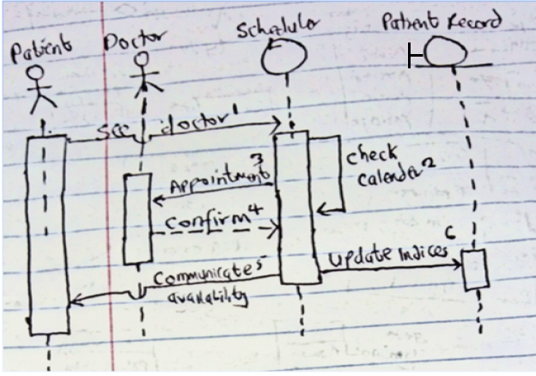
The figure two above relates to a “SEE DOCTOR’ use case scenario. The association between ‘SEE DOCTOR’ use case and an actor ‘patient’ reveals the behaviors that facilitate a sequence modeling for the software program. Specifically, the use case scenario above elicits six interactions that facilitate patient James Smart to book an appointment with Dr. Can. First, the use case scenario assumes that a ‘SCHEDULER’ is the control lifeline tasked to organize and schedule the interactions of an actor across the system. Therefore, the SCHEDULER receives an initial request from the patient actor to visit a doctor in the hospital. Consequently, the SCHEDULER confirms the availability of a doctor by checking the calendar and seeks an appointment on behalf of an actor-patient. On the other hand, the DOCTOR-actor replies to the message by confirming his availability. The SCHEDULER informs the patient-actor about the appointment to undertake his second visitation. The SCHEDULER also updates the PATIENT RECORD, which provides the boundary lifeline notation.
Figure 3: Taking Patient’s Test Case Use
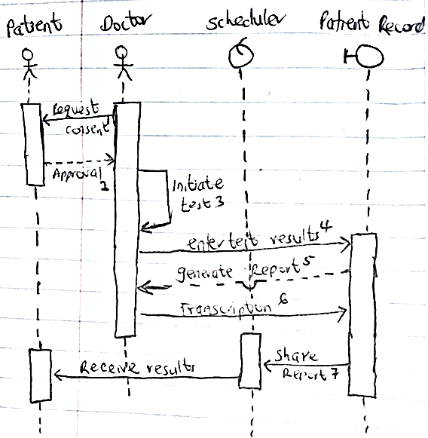
Figure three above relates to a second use case scenario that entails undertaking a medical test using the interactions of two actors to model the behavioral sequence in the system. The critical assumptions in the ‘TAKE TEST’ use case include taking consent from a patient-actor, initiate the testing process, recording the results to the database, and provision of the results using a SCHEDULER. Evidently, the ‘TAKE TEST’ use case scenario enhances the behavioral modeling because it displays the association of two actors that include a doctor who is an internal entity and an external user, the patient. First, the doctor actor interacts with the system by sending a message to a patient actor that regards the provision of consent. Consequently, the existing relationship between the patient actor and doctor actor facilitates the former to reply an initial message about the provision of consent.
Secondly, the doctor actor initiates a test process and enters the results to the patient record lifeline using the existing associations. Notably, the patient portal and doctor actor lifelines share an explicit association because the former provides the boundary notation in the system, which provides the database capabilities. The patient record generates a reply that entails a generated report that can be shared in the hospital’s central data storage. The doctor actor also provides the transcription to the patient record lifeline to facilitate the provision of prescription. Importantly, the patient actor lacks direct association with the patient record lifeline in the system, which necessitates the latter to disseminate the result and prescription to the Scheduler model. The patient actor receives the results of the test and subsequent prescription from the scheduler lifeline.
Developing Activity Diagram
An activity diagram is another tool used in UML that facilitates system architecture to model the behavior of the various users of a hospital-related EHR Sharing program. The activity diagram tool provides a model of a flowchart that utilizes special shapes to indicate the workflow (Pauline et al, 2003). The prominent workflows inherent in a UML modeling using an activity diagram relates to the ‘start/end’, ‘action’, ‘decision’, and ‘split/join’ tasks (Satzinger, Jackson, & Burd, 2015). The subsequent activity diagram modeling utilizes a ‘solid circle’ to signify the start of the diagram, ‘solid circle with a ring’ indicates the end of a task, and a ‘rounded rectangle’ depicts the particular action taken in the process. Equally, a ‘diamond’ shape manifests the decision that an actor in the system takes and a ‘thick bar’ has been selected to demonstrate a split in an activity.
Figure 4: Activity Diagram for Test Taking Workflow
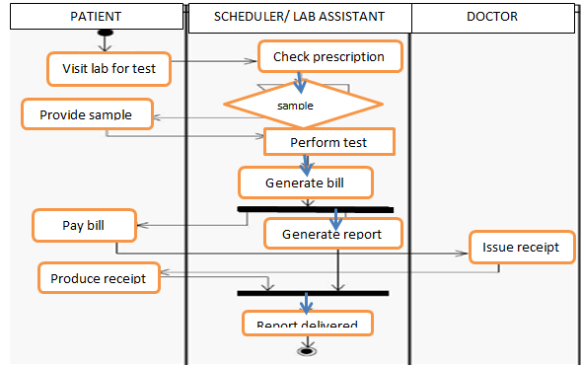
Figure 4 above depicts a workflow process that involves a laboratory test process in a hospital. The activity diagram above reveals the process begins after the patient receives doctors’ message to undertake a laboratory test. The patient visits the laboratory and provides the laboratory technician with a prescription from the doctor. The laboratory technician decision is to request a sample from the patient to undertake a test procedure. Using the laboratory technician generates a bill, which necessitates the patient to make payment. The doctor generates a receipt after receiving the payment from the patient and facilitates the closure of a test procedure.
Figure 5: Activity Diagram for Admission Process
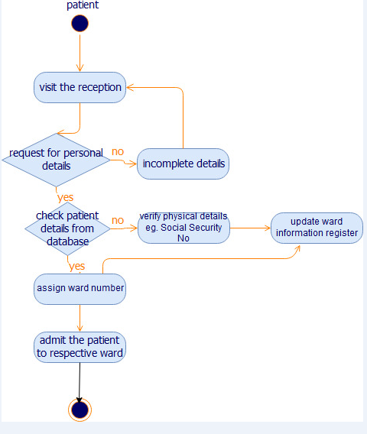
Figure 5 above is another model of activity diagram that relates to the procedures involved in the admission of a patient to a hospital ward. The patient initiates the workflow by visiting the receptions. At the reception, the nurse request for the patient’s identification details and confirm the data from the system’s database. The database confirms the doctor’s transcription to have the patient admitted for in-patient facilities. However, a discrepancy between the patient details and database report requires the receptionist/nurse to verify the records on the hard copies. Consequently, the nurse assigns the patient ward registration number and updates the general information register to rectify the discrepancy. The process terminates after the patient is admitted to the respective hospital ward.
Developing Non-Trivial State Diagram
A state diagram is a dynamic modeling tool that depicts the behavioral changes of an object in a UML class. According to Goodwin (2012), an object is characterized by its behavior and the current state of activity. Therefore, a state diagram model merits because it aims to portray the possible states of an object and possible transitions to shift the current status quo (ibid). System architecture uses a state diagram to modify the behaviors of an object to achieve a state that satisfies the properties of transition. In figure 6 below, the system designer uses ‘rounded rectangles’ to represent the conditions that satisfy the attributes of an object. Alternatively, an ‘arrow’ represents the transitions between distinctive states.
Figure 6: State Diagram for a Discharge Process
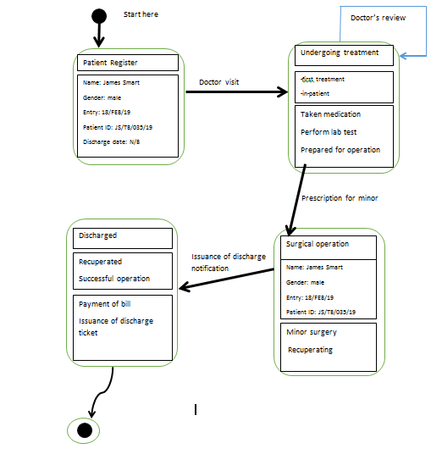
Figure six above reveals four states evident in a patient discharge process. The patient details are recorded in the registration database. The visit by a doctor transition the patient’s states to undergo treatments using several interventions that include a surgical operation. Further, the prescription to undertake a minor surgical operation is a critical intervention that changes the state of the patient in a hospital to a surgical operation. Moreover, the patient receives a minor surgery and recuperates for several hours. A positive progression warrants the issuance of a discharge notification from a doctor. The patient pays for the hospital bill and receives a discharge ticket, which allows him to exit the hospital. The treatment process terminates after the patient leaves the facility.
Concisely, the use of UML tools facilitates the system architectures to undertake effective static and dynamic modeling capabilities. A profound static modeling tool relates to a class diagram that depicts the three compartments of the respective class. A system designer models the class compartments to incorporate the respective class name, attributes, and the operations of an object. Importantly, the use of UML tool to model the software architecture merits because it provides a robust blueprint and communicates the aspects inherent in a hospital-related EHR Sharing program. On the other hand, multiple tools that enhance dynamic-based modeling of software architecture include the use of a sequence diagram, activity diagram, and state diagram. Notably, both the activity and state diagrams merit because they facilitate a designer to outline pertinent workflow in a system as well as the possible transitions during the implementation phase.

References
Ehlmann, B. (2009). Object relationship notion (ORN) for database applications, New York, NY: Springer
Ferreira, W. (2017). Computer science distilled: Learn the art of solving computational problems, Las Vegas, [Nevada] : Code Energy LLC,
Goodwin, D. (2012). Modeling and simulation, University of Bedfordshire
Iribarne, L. & Almendros-Jimenez, J. (2007). “Describing use-case relationships with sequence diagrams,” The Computer Journal, Vol. 50, Issue 1, pp.116-128
Loudon, K. & Loudon, J. (2014). Management information systems: Managing the digital firm, (13th Edition), Boston, MA: Pearson Education
Pauline, W., Michael, S., Alan, S., Rob, P., Lachlan, M. & Rick, D. (2003). OPHELIA: An architecture to facilitate software engineering in a distributed environment, 15th International Conference on Software and Systems Engineering and their Applications (ICSSEA), December 3-5, Paris, France
Satzinger,J., Jackson, R. & Burd, S. (2015). System analysis and design in a changing world, (7th Edition), Boston, MA: Cengage Learning
The Open University (2011). Modeling object-oriented software-An Introduction, AUTHOR. www.open.edu/openlearn/ocw/mod/oucontent/view.php?printable=1&id=2776

